|  |  |  |  |
| --- | --- | --- | --- |
| BSc Computing (All Pathways) CSY2028 Internet programming | | | |
| Agreed Date for late submission: | **Sunday 22April 2017** | Module Tutor: |  |
| Student ID: | 17429433 | | |
| Video Link: |  | | |
| Student Name: | Madhav Sapkota | | |

UNID: 17429433

The University of Northampton

Password: admin

Username : admin

|  |  |  |
| --- | --- | --- |
| S.No | Title | PageNumber |
| 1 | Introduction | 3 |
| 2 | Testing Evidence | 4 |
| 3 | Design and technical Documentation | 11 |
| 4 | Evaluation | 12 |
| 5 | Conclusion | 13 |
| 6 | References | 14 |
| 7 |  |  |

Introduction:

This is the assignment in which the Northampton Tech Jobs has provided all the html and css layout for adding the functionality to this website.The functionality tasks of this website is carried out through the php basic programming concepts along with using database query codes.

The Original website provided by the Northampton Tech Jobs is to be transformed into new way by adding the various types of functionality .The company has needed two section of view i.e admin section view and the usersection view.Admin is that section who has access to handle this website say,driver of any vehicles to deliver the company information,business strategy to make reach among the global. The responsibility of the admin section is to handle, contents of website ,deliver the suitable information/business rules of any business motive organization or else ,viewing the responses from the user and the contact information from the user and so on.Similarly usersection is that section from where people can view all the information,contents,policy ,news posted from the admin. The functionalities needed for this website to appear as good website, intially it should be characterized of protected administration area from where admin can add jobs, add category, assign jobs to categories, editing an existing jobs in case mistakes are done, deleting jobs, editing existing categories, deleting categories,view application for each jobs posted company. Similarly, from the public visible front ends candidates can browse all the available jobs in the company, filtering jobs on the basis of category and view application for jobs.

The completion of this website is through testing of many webpage, initially there was a lot of bugs during the functionality implementation like the checking the login process, signin process, displaying the posted articles.The seperation of the category of this articles cannot be solved because of many bugs even trying many times.Similarly searching criteria for the articles, maps (location) information in the website cannot be displayed in the website like the previous errors.

After completely solving website funtionalities without bugs, this website becomes able to have the secure admin login system and the secure user login system .The admin section can add jobs, add category, assigning jobs to category, editing existing job if mistakes are done, deleting categories, editing existing categories and viewing application for each jobs. Similarly the user section should have to login in the system to view the content of this website, if user hasnot login information ,he/she should have to signin by filling the username and password with confirmation password, from this signin process username and password is stored in the database then only user become able to login to the system(user section) by putting his/her username and password which they have stored to make signIn in the database by pressing login button.At the usersection ,an user can see the jobs information posted by company i.e the admin and the contact form from which user can make connection with the admin section.As I have previously mentioned because of bugs, filtering jobs by selecting a category cannot be able to be included in this website in the user section. All the webpages in this websites are dependent on one another.Thats why, the changing one webpage leads to change of the whole pages.In sum many of the functionality of the websites are solved.

Testing Evidence:

When webpages are completed,all codes of each pages are tested sucessfully .Intially there was many bugs ,after making too much changes in the pages, web pages become free of bugs and that code become able to solve this problem.

Admin Section login check:



When login is sucessful then it goes to the home page of the admin section where one two buttons are placed on the navigation part which are’ Home’ and ‘LogOut’.And this page is featurized of different links as Adding Jobs,Adding Category,EditingExisting Category,Deleting Categories,View application for each jobs.



Adding Jobs: When the addingJobs is clicked it goes to the addjobs.php then the form is opened which contains the JobCategory,JobType,Location ,deadline ,description based on the measure of suitability of button,somewhere there is only the text button and at somewhere there is select box .When a submit button is pressed,then the jobs is added to the database and user can see the jobList.

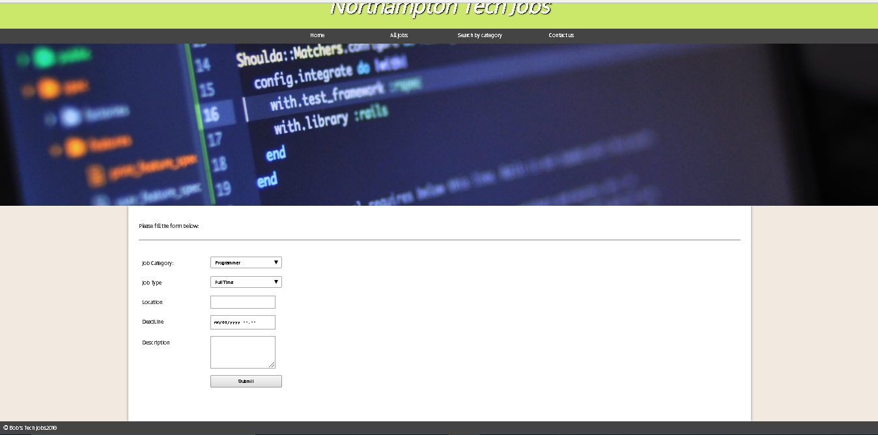

AddingCategory: Clicking of addingCategory link takes to reach at form which contains only one field and submit button.Admin can use this button to add category of the job in the database and that can information can be seen by user.

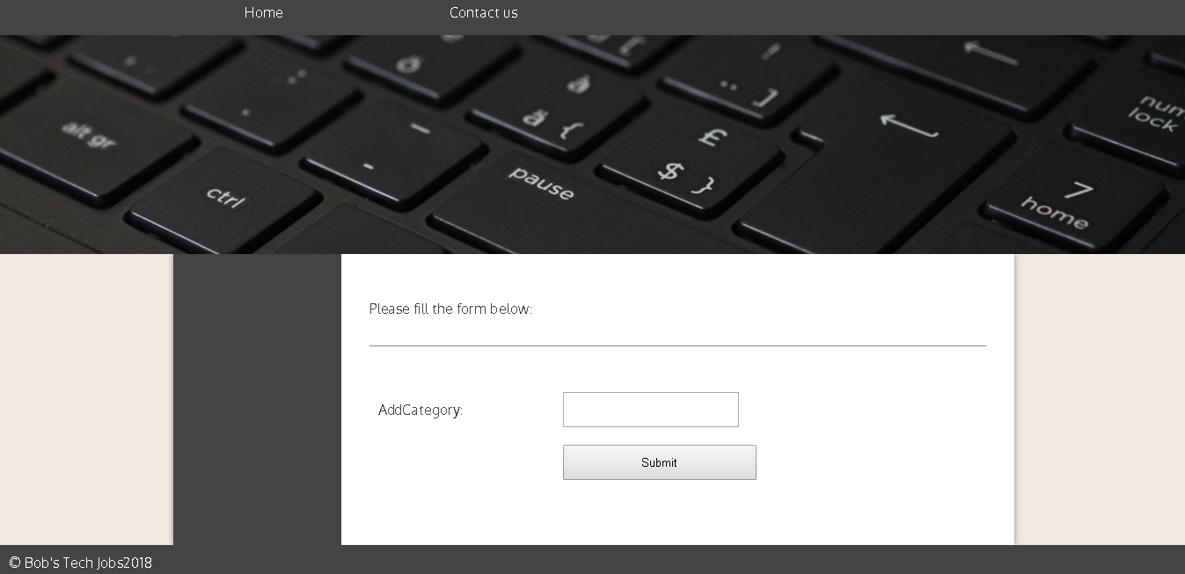

Editing existing Categories and Jobs: This is the link at the admin main page where admin can edit the existing Categories and Jobs ,if there were mistakes in previously submitted form for the jobs and Categories.

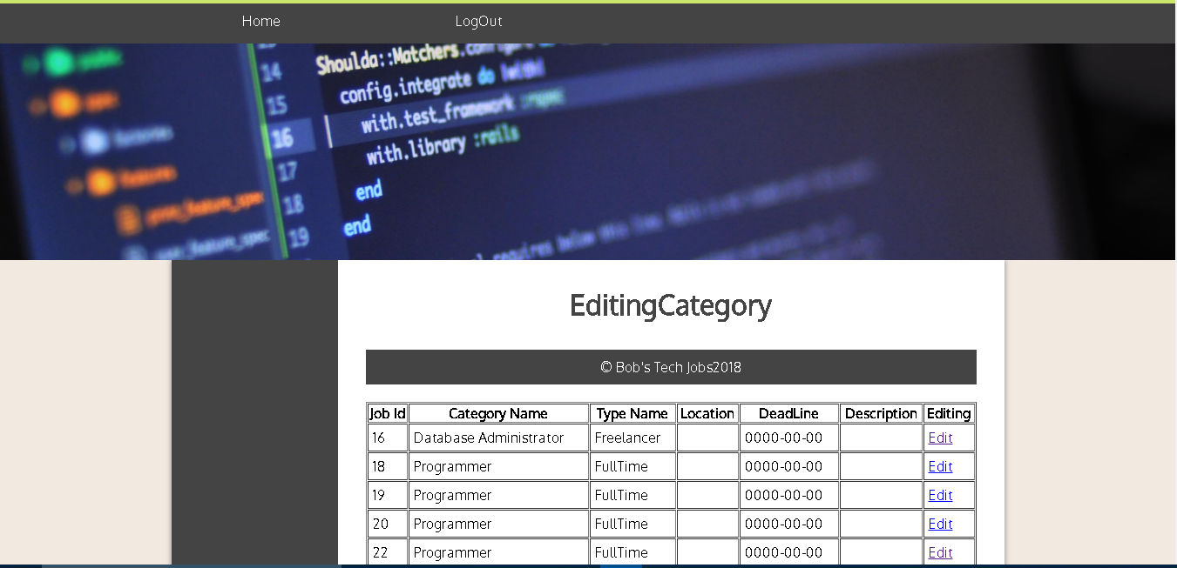

Deleting Categories and Jobs: This is the link for deleting the categories and jobs which are already submitted in the above sections.When the delete button at the righthandside of each row is clicked, that row is deleted and the Delete Sucessfully message is also shown.

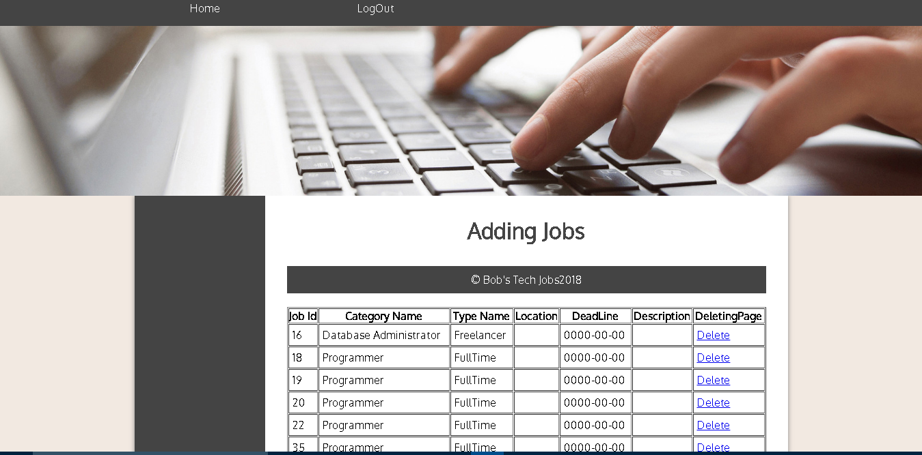

View application for each job: This link takes admin to see the information obtained from the contact form of user .Information here is FirstName, Surname, JobCategory, JobType, Date of birth, Email, PhoneNumber and Resume.

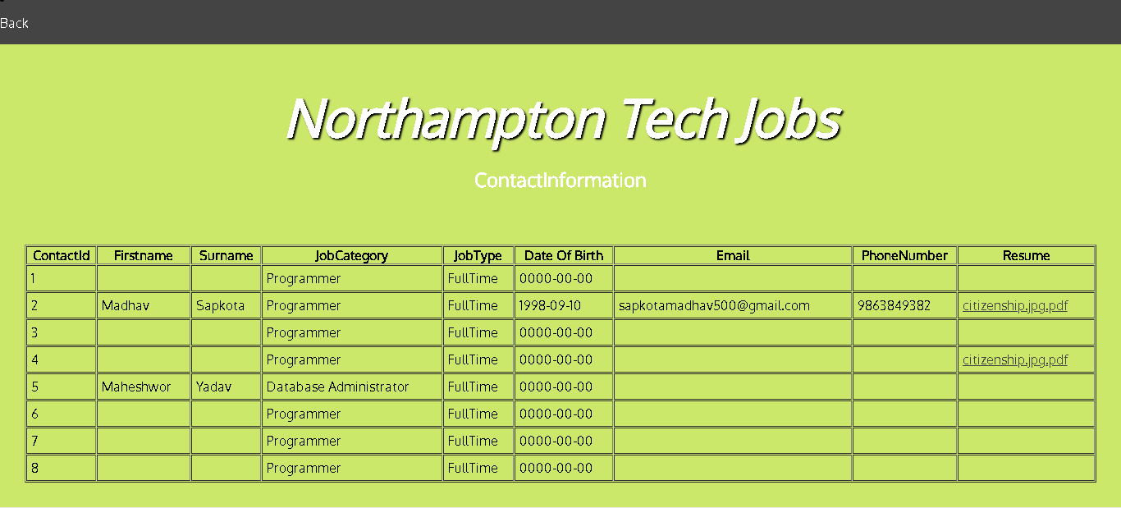

When the back button placed at the top of the page is clicked,it comes at the main panel of the admin section,after pressing the logout button ,admin is out from the admin section.

To move to the userSection ,an user should choose the userLogin button which is under the ul form in Login Button.An user should have to login with right username and password to enter into the user main page.If the user information is in the database, he/she should have to put information in database by pressing the signin link and submit the username and password with confirmation password.

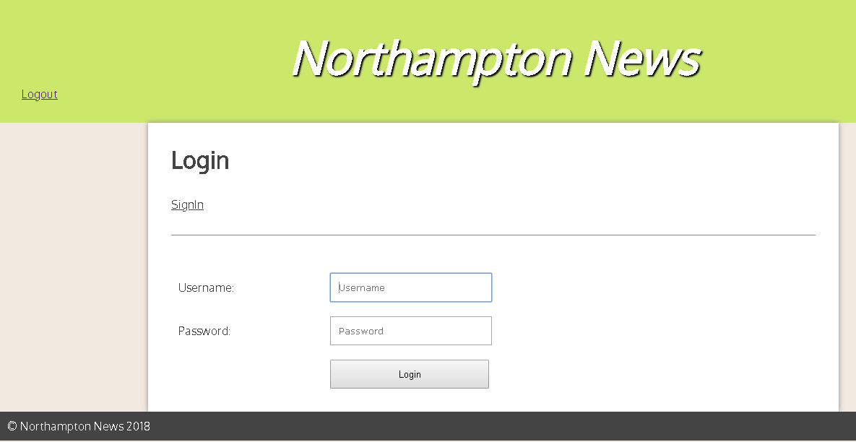

When the logout button is pressed,it comes out from the admin section.And Comes at the main page of the website.To enter into the user section.At first user should pressed loginUser button,then it moves to login form .

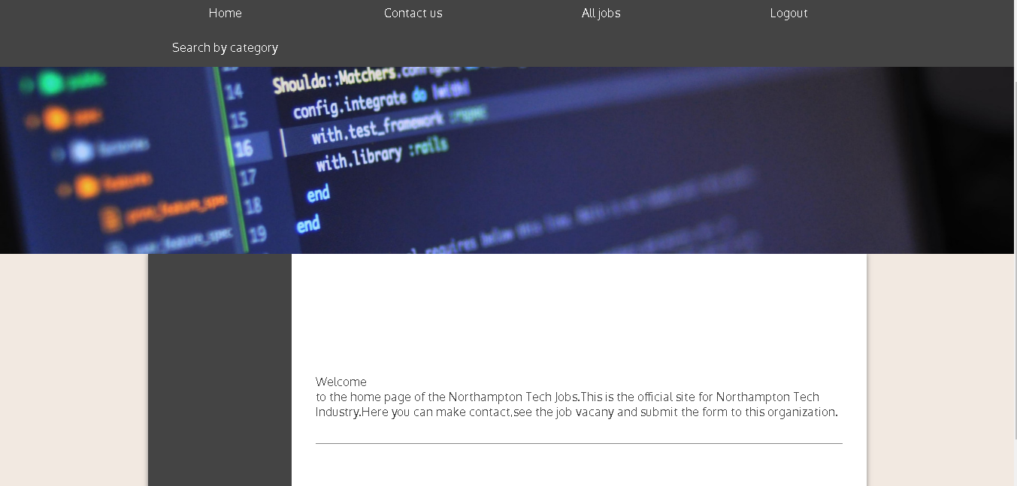

Similarly when all jobs button is clicked then all jobs posted by admin are listed in this link in the tabular format are seen.And a user knows that the company has vacany for this post.

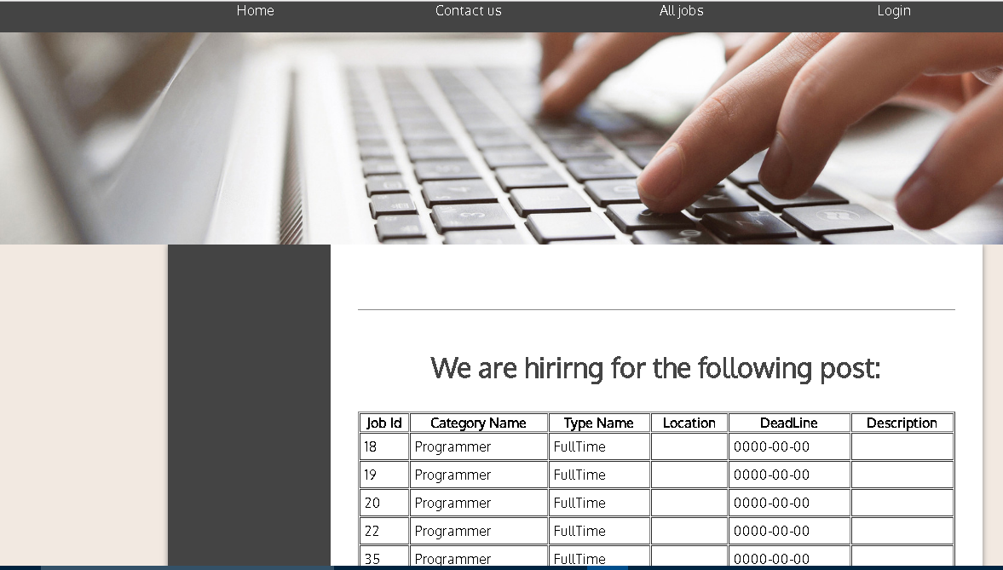

When a contact button is clicked,then form is opened in the user section,where user can send some information to the admin/website along with by submitting resume .

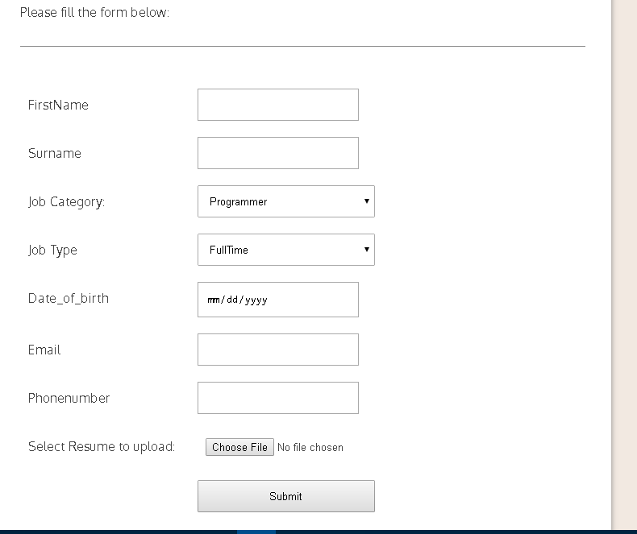

Design And Technicial documentation:

For making the functionality of this website different types of the php and SqL database query is used.Inorder to check whether the entered username and password is valid or not test variables are used.Intially for this we inserted the username and password for login at admin section and user section.If the entered value in the form and getted value from the database is true in either section or admin section ,then the operation can proceed.Many types of database query of php has been used such as insert,update,delete ;insert query is for insertion of many types of data.Update query is for

editing for the category of the jobs in the admin section.Delete query is for deletion of some job desciption,category description from the websites.

For the login operation to be successful in both the backend and the front end user,intitally we have to inserte theusername and password in the database and send the value of username and password from the database and compared the getted value of both from the form and the database table.When the username and password is valid,in admin section and user section then the operation can move ahead.To add new field to any page we have a new field in the database by inserting its datatypes and the size.Then the required pages can add an extra field name inside the query and in the get variable and also in the form.

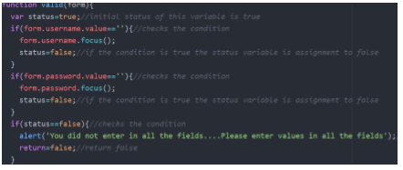

The codes of above image clearify that inorder to move in next execution phase,the username entered by the backend user in the form and the inputted data from the database query must be true.If the conditon cannot be meet up,last statement is executed and the alert message is pop out by saying “You did not enter the valid fields.Please enter the values in all the fields”.

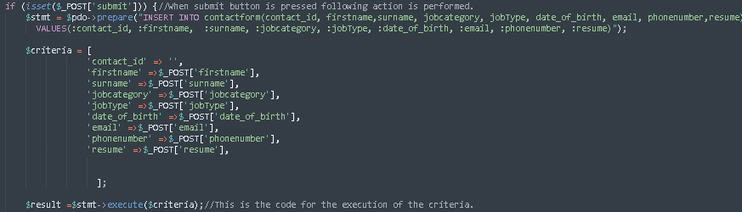

This image is for the addition of the new fields in the contact page.The database query use we can inset statements,for the adding of the new fields at first it is necessary to add in the relational database table.From the $POST variable all the data is stored in the database table and that datas are getting out from thedatabase by the use of the $GET variable.This is the similar steps for the addition of new fields in many respective pages of this website.

Password_verify code is used in this website for the adding the security purpose in this websites.

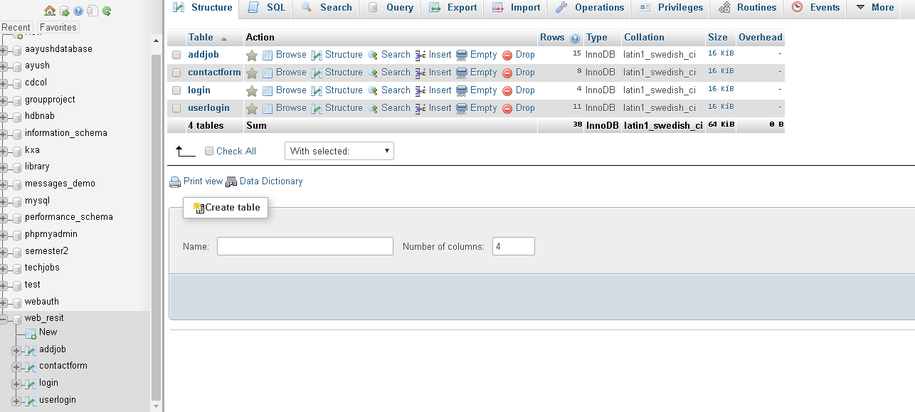

Fig: Database table

Evaluation:

There is well implementation of login page for the both front end and the backend user.Intially when the page loads the login form is appeared in both the admin section and the user section.When both either the admin or user login into the system,the main page appears in both section.

The improvement needed might be completing the user section i.e viewing the selected categories and appears in the selected pattern where user has done.The developer has made this whole site very simple in dynamic ways.Some of the things like adding the location of job areas , comment ,adding the button of the social sites has not included in the website because of time limit.If there was enough time,perhaps almost part of the advanced section could have been solved.

The codes are written in very clearly and precise manner so that any changes done in code in future to this website is not difficult.Complex type of codes have not used in this project as it is written in the simple and easy way.Each webpages are dependent upon each others i.e codes of the header,footer connection are placed in separate file so that bringing changes in the code only makes the future designer to avoid loss of time.The connection of that page is placed in every pages of the website.So only changing the content of code in either the header,footer file lead to change in the multiple files such as contact informamtion,adding ,deleting,editing Category,and so on. There is comment provided on the coding section so that future developer of this website can easily understand this code and can enhance in beautiful way, where it is necessary.

Conclusion:

The purpose of this assignment was to test the knowledge of the php coding and the sql database coding.Both in the admin part and at the user part we have to add functionalities for making dynamic.We have contact table,jobs table,login and logout in both the section.Database queries such as Insert,delete,update are included in the php code.Forms are made for the directly insertion ,deletion,updation in the database.Various testing parts were included in each pages;the dependancy rate of one page to another is high in this websites.During ,intially phase too many bugs were found out during the web pages load time,and hit and trial methods finally become the milestone for solving these types of problem.If there wasnot limited time,perhaps many of the advanced section tasks and displaying the content of selected categories can be sucessfully displayed out.Similarly use of the social sites linkage such as comments,like,share can also be included.On the sum,this websites appear as good functionality website.

References:

Newest 'php' Questions - Stack Overflow. 2018. Newest 'php' Questions - Stack Overflow. [ONLINE] Available at: <https://stackoverflow.com/questions/tagged/php>. [Accessed 8 April 2018].

wikipedia php script - Google Search. 2018. wikipedia php script - Google Search. [ONLINE] Available at: <https://www.google.com.np/search?q=wikipedia+php+script&oq=%3Dwikipedia%2Fphp&aqs=chrome.3.69i57j0l5.11019j0j4&sourceid=chrome&ie=UTF-8>. [Accessed 8 April 2018].

nile.northampton.ac.uk. 2018. No page title. [ONLINE] Available at: <https://nile.northampton.ac.uk/webapps/portal/execute/tabs/tabAction?tab_tab_group_id=_3_1>. [Accessed 8 April 2018].

Writing reports — University of Leicester. 2018. Writing reports — University of Leicester. [ONLINE] Available at: <https://www2.le.ac.uk/offices/ld/resources/writing/writing-resources/reports>. [Accessed 10 April 2018].